**MAWLANA BHASHANI SCIENCE AND TECHNOLOGY UNIVERSITY**

SANTOSH, TANGAIL-1902



DEPARTMENT OF INFORMATION AND COMMUNICATION TECHNOLOGY

**Course Title: Computer Based Numerical Method Lab**

**Course Code: ICT-2102**

**Lab Report on: Newton-Raphson Method.**

**Lab Report No: 04**

|  |  |
| --- | --- |
| Submitted By | Submitted To |
| Name: Kuldip Saha Mugdha  ID: IT-22018  2nd Year, 1st Semester  Session: 2021-2022  Dept. of ICT, MBSTU | Dr. Mst. Nargis Akter  Professor  DEPARTMENT OF INFORMATION AND COMMUNICATION TECHNOLOGY  MAWLANA BHASHANI SCIENCE AND TECHNOLOGY UNIVERSITY |

**Date of Performance:**

# Date of Submission:

**Experiment no:** 04

**Experiment name:** Newton-Raphson Method

**Objective:** The objective of this lab report is to use the Newton-Raphson method to find the root of the nonlinear equation:

ex−e−2x+1=0

**Materials:** MATLAB

**Code:**

% Define the function f(x)

f = @(x) exp(x) - exp(-2*x) + 1;

% Define the derivative of the function f'(x)

df = @(x) exp(x) + 2*exp(-2*x);

% Initial guess for the root

x0 = 0.5;

% Tolerance for stopping criterion

tol = 1e-6;

% Maximum number of iterations

max_iter = 100;

% Initialize variables

x = x0;

iteration = 0;

% Newton-Raphson iteration

while abs(f(x)) > tol && iteration < max_iter

% Update x using Newton-Raphson formula

x = x - f(x)/df(x);

% Increment iteration counter

iteration = iteration + 1;

end

% Display results

if abs(f(x)) <= tol

fprintf('The root is approximately x = %.6f after %d iterations.\n', x, iteration);

else

fprintf('The method did not converge within %d iterations.\n', max_iter);

end

% Display the value of f(x) at the root

fprintf('The value of f(x) at the root is %.6f.\n', f(x));

**output:**

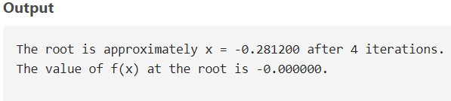

**Discussion:** This method is highly efficient and provides rapid convergence when the initial guess is sufficiently close to the true root. However, it requires that the derivative of the function is available and that the initial guess is near the root to avoid divergence.